INCUBATION AND BROODING IDEAS FROM THE M&M GUYS!

A few days ago, Michael Sayre and I were chatting about a few things we have learned the last few years that have dramatically increased our hatching and brooding efficiency. After we were done, I realized that we have been doing this every year since 1972… 48 years and my how things have changed. I started with the old metal Montgomery Ward’s round still- air Incubator and I still have one for sentimental reasons.

In the 1990s, I finally saved up enough extra cash to buy a GQF knockoff-type incubator that my old friend, Victor Hakes of Twin City Supply, made at that time. I was the double wafer style thermostatic control, but it had the then-coveted 3 automatic turners and a hatching tray. I liked Victor’s version over the GQF units at the time because it had better air flow and ventilation which meant it had air vents at the top and the bottom to flow fresh air through the whole unit. This was a feature the early GQF models lacked. I hatched thousands of chicks, ducks, geese, pheasants, and quail in that unit and in 2012 sold it to a friend and purchased a Brinsea Ova Easy 190. That was one of my biggest mistakes in the exhibition poultry hobby!

This Brinsea was a used unit and caused me nothing but trouble. After a few weeks, the automatic turner unit and temperature sensor went out and getting parts from Brinsea was a nightmare as I was not the original owner and I got no help from their American distributor. I used it as a hatcher only from 2012 until 2019 when I finally got in contact with the main office in England and was able to purchase a new and improved version of their automatic turner. Until that time, I used two Marsh Farms RollX incubators to set my eggs in and used the Brinsea to hatch in. I did this for seven years and would say I averaged about a 65-70% hatch rate. Now, I use it to set all my eggs and it is doing a great job for that purpose. I recently sold my Marsh Farms RollX to a friend to hatch Seramas in. They are great little incubators but I had too many and they needed to be used by someone!

I was blessed to have the resources of my daughter, Emily, who has a Master’s degree in Hatchery Management from the University of Arkansas to bounce ideas off of on ways to improve my incubation methods. The last few years Michael Sayre and I have been fixing and refurbishing old Redwood type cabinet incubators and completely replacing them with more modern, efficient electronic components. We have learned a few things along this journey that we would like to share that have helped us increase our hatch rates into the high 90’s and my personal hatch rate this fall/winter has been 100% for 5 weeks in a row. These ideas may work for you or they may not. We learned that you are never too old to learn and everything can be improved or done more efficiently. That might come from 15 years of brainwashing by my employer about always thinking of ways to do things better and more efficient!

Matt and Mike’s Hatching Rule #1- Your hatch rate will drastically increase if you use a separate machine to hatch and set your eggs in. There are several reasons for this, we believe. First off, the setting incubator stays cleaner and is easier to sanitize. For those of you setting notoriously dirty waterfowl, turkey, or gamebird eggs, my daughter says sanitation is key. Commercial poultry hatcheries are even moving toward this type of single-stage incubation to maintain cleanliness. It is also easier to maintain steady temperature and humidity during the setting period of 18 days for chicken eggs. We use no water in the setting incubators and maintain a temperature of no more than 100 degrees and not less than 98 degrees. Ideally 99.6 is where we try to stabilize at. Humidity varies between 20-30% with no additional water added in the fall and winter. In the late spring, I sometimes need to add water and we monitor the air sac on the 18th day which should be drying down to about 1/3 the egg size. We both believe that more chicks are killed in incubation by excessive humidity than lack of humidity! Every degree over 100 that your incubator gets to will significantly reduce your hatch rate. Also, high temperature is related to an increase in spraddle-legged chicks. A separate hatcher can be cleaned more effectively and humidity regulated better. I like my hatching machine to be at 50-55% humidity and 99.6 degrees in temperature. Water is added and vents adjusted to maintain these settings. The hatcher is cleaned after every batch and sanitized with Tek Trol spray. This is a broad spectrum, hospital-grade disinfectant that kills bacteria, viruses and fungi as well as stopping the growth of mildew within our ideal hot, humid hatcher conditions. Tek Trol is even proven to kill Tuberculosis-causing mycobacteria, which are usually impervious to most disinfectants. I currently use a refurbished Humidaire Model 21 Ostrich Hatcher that was gutted and converted to electronic heaters and thermostat. It has a stainless-steel water pan and top vent adjustments. I have it dialed in to precisely 99.6 and about 55% humidity and currently hatching 100% of the viable eggs moved into it on the 18th day. Michael Sayre likes the Leahy type hatchers and has great hatches with them as well running them at similar settings.

Rule #2- Why pay several hundred dollars for an incubator or hatcher and then use a cheap, inaccurate thermometer to set the temperature? We have found that almost all units vary widely in temperature setting and even between the setting and hatching trays. Most thermometers that come with incubators and even fancy digital thermometers are inaccurate several degrees one way or the other. We like the VWR Calibration Thermometer as it has a green liquid bottle that takes the temperature, and this mimics the egg. I set the bottle right in the hatching or setting tray so I know precisely the temp of that tray.

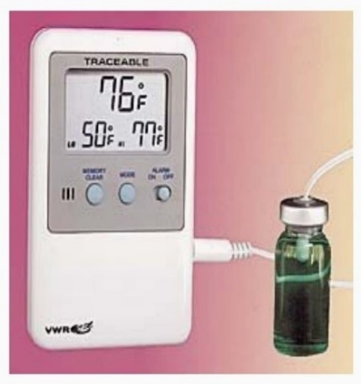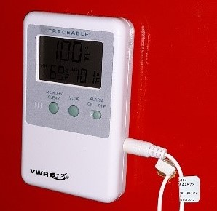

https://www.amazon.com/dp/B001UHZXKE/ref=cm_sw_r_fm_apa_fabc_pio3FbBNTS0F1

This will be the best purchase you will ever make. Be aware they are over $100, but you will know the true, exact temperature your eggs are experiencing in your incubator and hatcher which is critical for great hatching percentages.

Rule #3- Proper air flow and ventilation are critical to the hatch rate. The older Redwood incubator manufactures knew that, and that is why they graced the halls of hatcheries that made a living selling day-old chicks. Leahy, Petersime, Humidaire, and Robbins all knew this and that is where most of the current hobby incubators falter. A good incubator will exhaust stale air and replenish with fresh air. When we refurbished our older models, proper air flow is critical! This is the biggest issue with most hobby incubators sold today and it limits your hatch percentage. Like I mentioned above, the vents must bring fresh air in and exhaust stale air out. In most incubators and hatchers, air is brought in behind the fans and circulated then through the incubator and exhausted out by the bottom vents. I will detail it more below in the section on refurbing a GQF.

Rule #4 Matt and Mike, how can I fine tune my GQF Style incubator to help improve my hatch percentages?

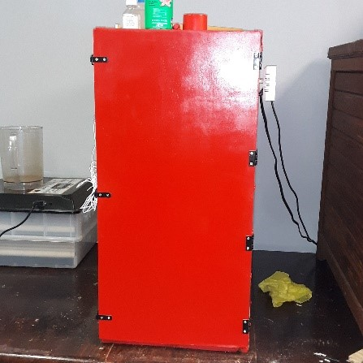
Paint your incubator with an enamel paint to seal it up help it retain heat and resist moisture and mildew. This also makes it easier to clean than the stain that comes on it. Mike likes International Harvester Red, some prefer John Deere Green!

Make sure there are vent holes with metal slides on both the top and bottom of your GQF. This will help adjust fresh air flow inside the incubator. Also, Mike cuts vent holes in the top tray that holds the water pan to allow air to flow downward and not deflect off the front and then downward.

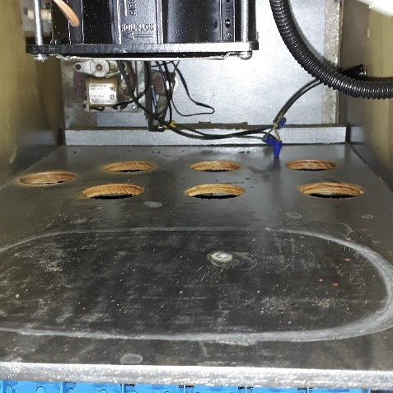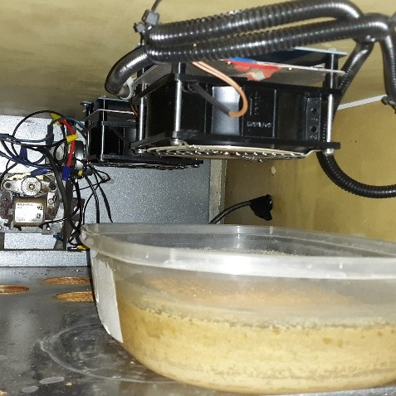

This well greatly increase air flow and even up the heat distribution in a GQF type incubator. On the ones we refurbish, we change out the fans and heat elements with a kit from incubator warehouse that you see above. This a subject of a whole other article but we believe it makes them a better unit as you have good electronic controls and cycled, even heat distribution with no hot or cold spots in the incubator.

Rule #5 Matt and Mike, I can't find an old Redwood to refurbish. What brand of incubator would you buy?

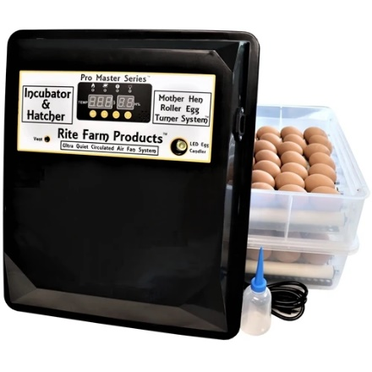
We both like the incubators made by Rite Farm Products. For a beginner or small-scale breeder, we like the Rite Farm Products Pro Master Series 120 Chicken Egg Incubator. Buy two and use one strictly as a hatcher! Michael uses one of these and I bought one as well. Great to set eggs in but still prefer a separate hatcher!

https://coopsnmore.com/collections/chicken-duck-goose-pheasant-supplies/products/rite-farm-products-pro-master-series-120-chicken-egg-incubator

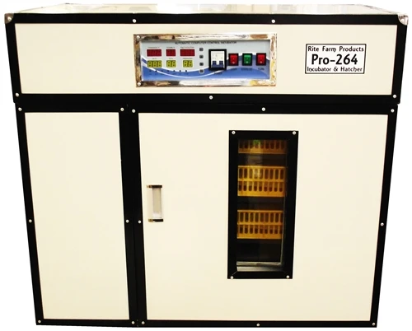
For those wanting a little more capacity, Rite Farm Products Pro-264 Cabinet Incubator & Hatcher! We love these incubators as heat and humidity is controlled by an exhaust fan. That provides proper circulation and ventilation like the big commercial incubators! They also have a UV sterilization feature which is unique to the hobby type incubators. They come in varying sizes and we have talked to several people who use them and not one bad review. Although you can hatch and set in the same unit, I would use a separate hatcher to contain the mess. If we were to buy a new one, this is the one we would buy.

https://coopsnmore.com/collections/chicken-duck-goose-pheasant-supplies/products/rite-farm-products-pro-264-cabinet-incubator-hatcher

Rule #6- Brooding your chicks both safely and efficiently is becoming a challenge. The loss of incandescent light bulbs and the danger of using heal lamps made my partner Mike and I go to the drawing board and redesign my old brooders Zelotis Eschmeyer made me in the 1990’s. I had brooded a bunch of chicks in them but found getting a steady supply of incandescent light bulbs was hard and temperature regulation was not an exact science by any means. Michael devised a small unit that used a LED light and a ceramic heat emitter with a thermostat to control the heat emitter. Lots of trial and error here but we think we have it improved to a satisfactory state. The links to the items we use are listed below and you need a big enough heat emitter to get the brooder to temp. We find the 250 watts works great for day-old chicks at 90 degrees and the 150 watts work great for older chicks between 70-85 degrees. Emily recommends to her small flock producers that you reduce the temperature of the brooder by 5 degrees for each week of life until ambient temperature is achieved. However, she strongly believes the chicks will tell you more about brooding temperature than relying on a thermostat. Cold chicks are loud, they huddle, and smother. Hot chicks are sleepy and splayed out trying to release as much heat as they can. Comfortable chicks are active, chirping, and well dispersed throughout the brooder. Regardless if your thermostat reads 90 degrees F, if the chicks are huddled next to the heat source, piling, and screaming: they’re cold. We keep the heat emitters in the top of the brooder far enough away from the chicks as to not burn them. Having bumped them with my hand, I can tell you they will leave a sizzle mark on you!

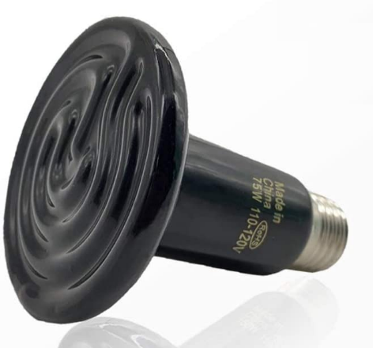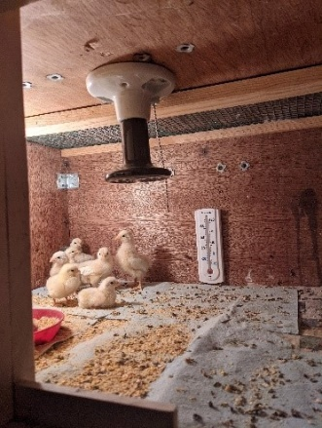

https://www.amazon.com/OAPYH-Ceramic-Emitter-Reptile-Infrared/dp/B08MWF2YTD/ref=sr_1_7?dchild=1&keywords=250+watt+ceramic+heat+emitter&qid=1608685508&sr=8-7

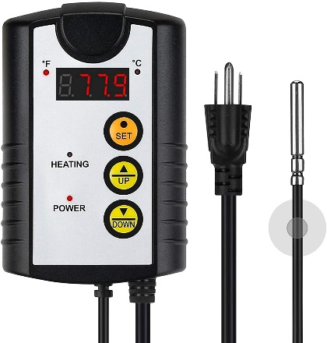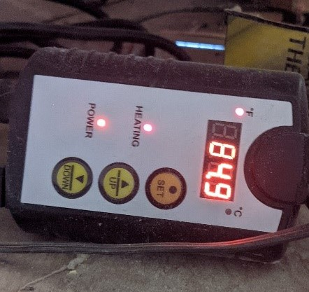

https://www.amazon.com/gp/product/B08DNMZ2C7/ref=ppx_yo_dt_b_asin_title_o08_s00?ie=UTF8&psc=1

I hope this little article will be of some help or at least inspire some of you to think about your hatching and incubation procedures and help you maximize your efficiency. We receive no compensation for endorsing the products above, and we will definitely tell you about all the ones that didn’t work! These are our opinions and experiences - take that for what it’s worth. We are both old and grumpy and will probably shoot you rather than argue but your feedback is taken accordingly.

Sincerely yours in the crazy Exhibition Poultry Fancy,
M&M Exhibition Poultry
Matt Lhamon with lots of input from Michael Sayre and Emily (Lhamon) Shoop.

